Republic of the Philippines

**SOUTHERN LEYTE STATE UNIVERSITY-BONTOC**

San Ramon, Bontoc, Southern Leyte

Website: www.slsuonline.edu.ph

Telefax: (053) 382-3121; Email: slsubc@yahoo.com

**MODULE 1**

*First Semester AY: 2020-2021*

|  |  |  |  |  |  |
| --- | --- | --- | --- | --- | --- |
| **Name:** | **Jeca G. Calope** | | | **Rating:** |  |
|  |  | |  | |  |
| **Course/Year/Section:** | | **BSIT-3-A** | **Date Submitted:** | |  |

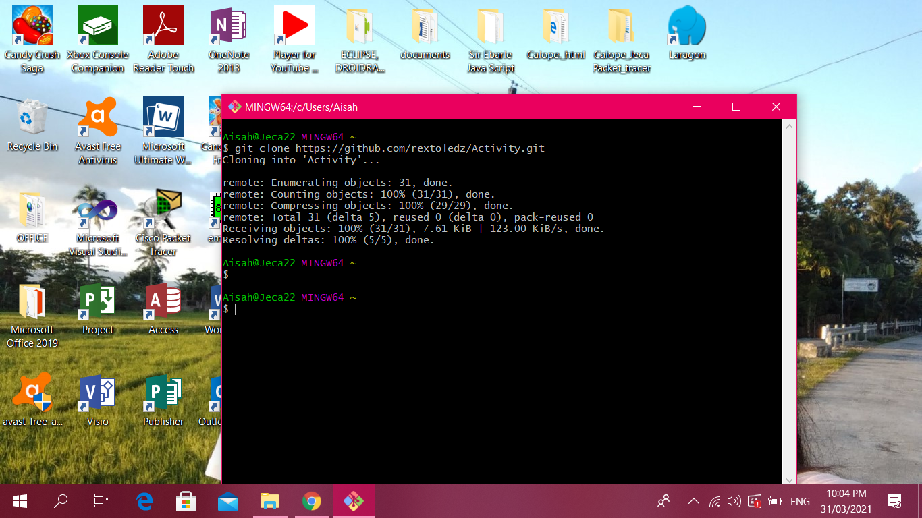

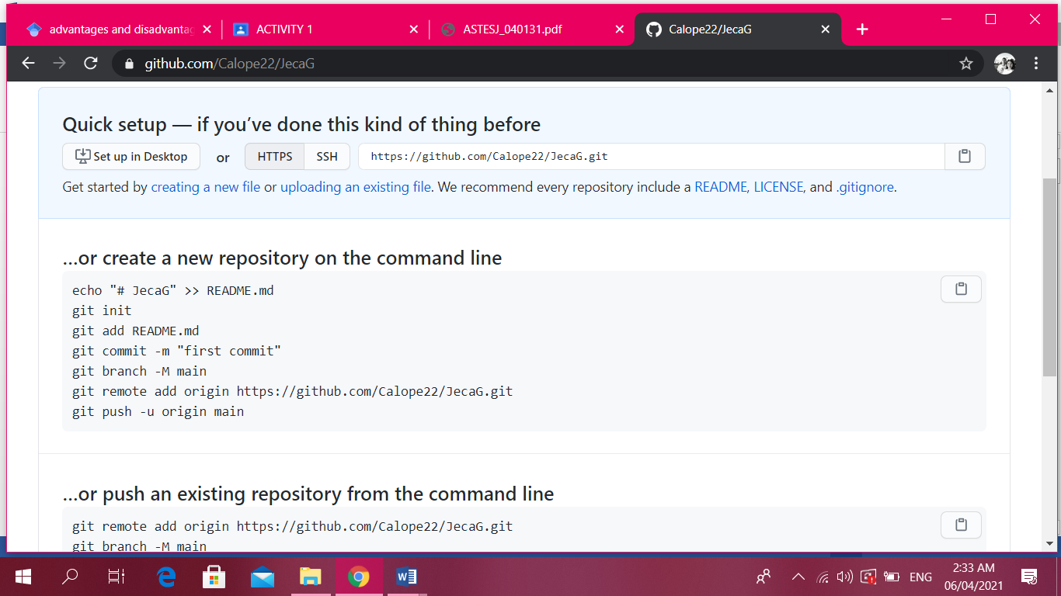

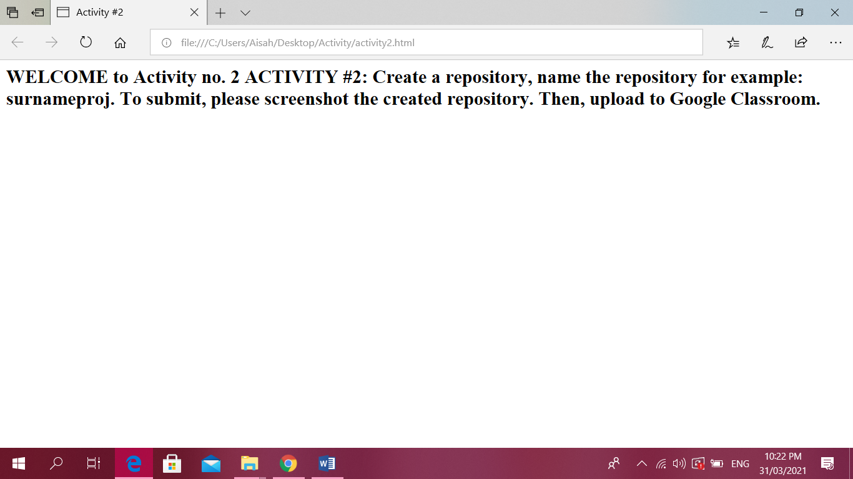k

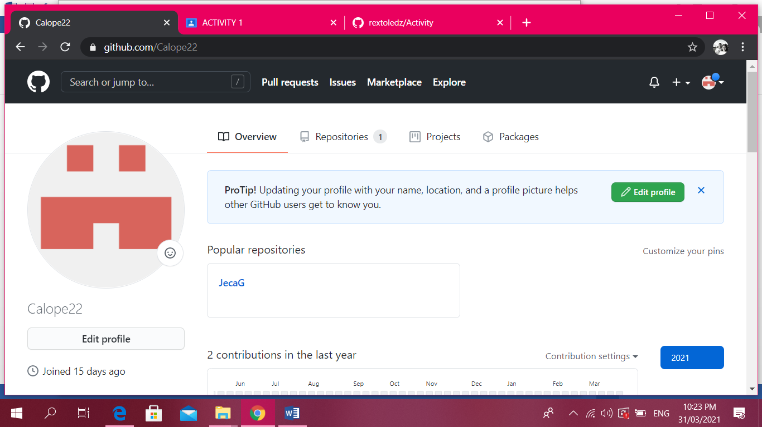

**Activity No. 2**

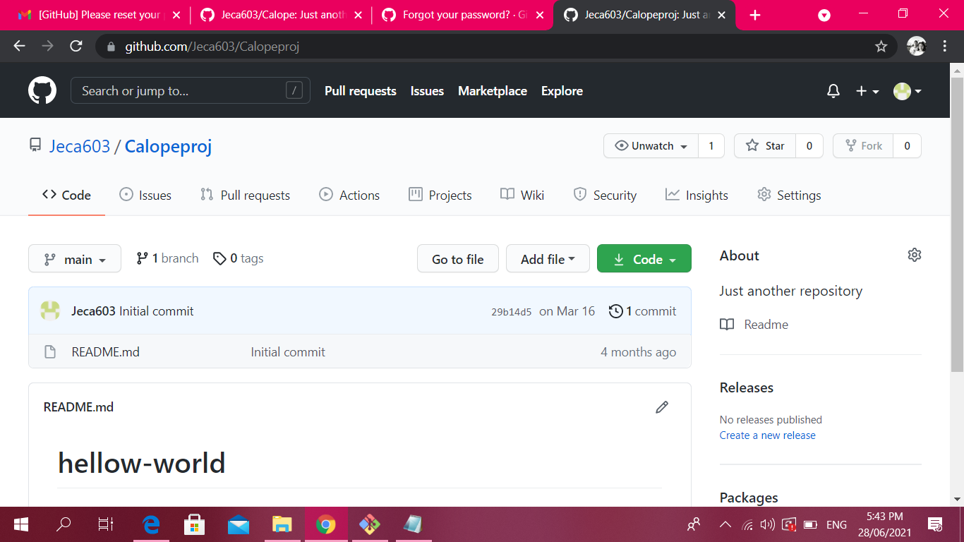

**Activity No. 3**

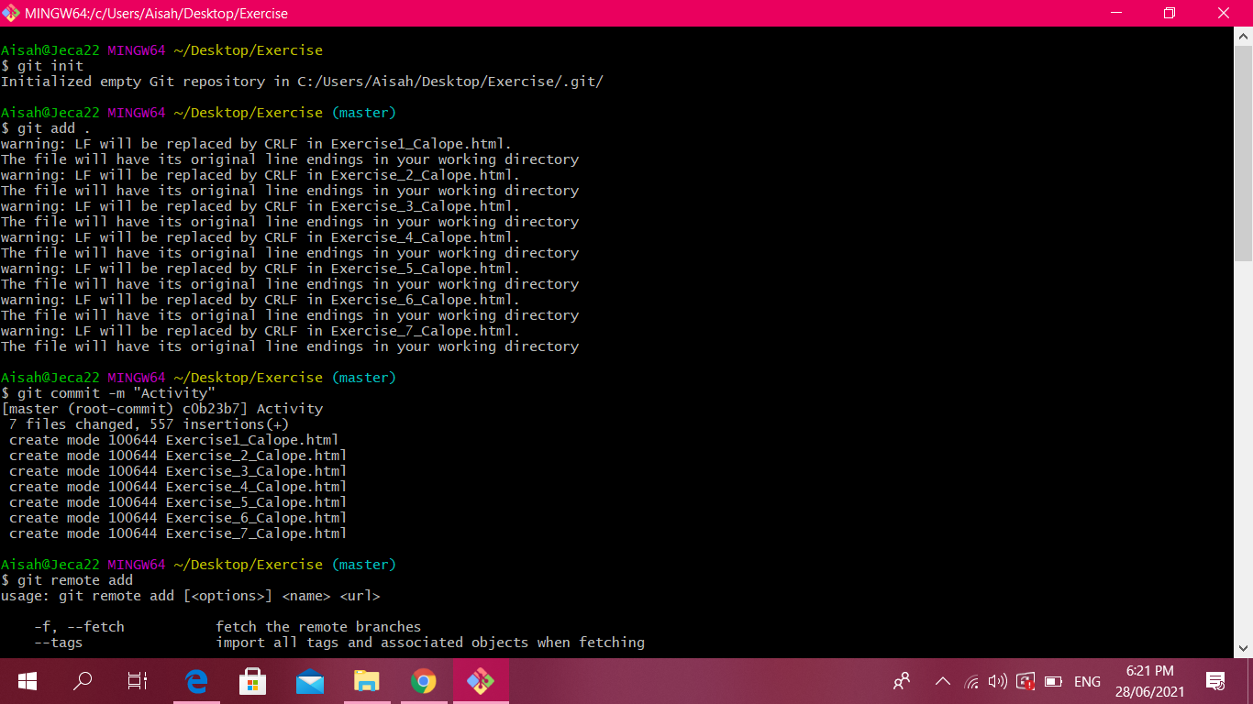

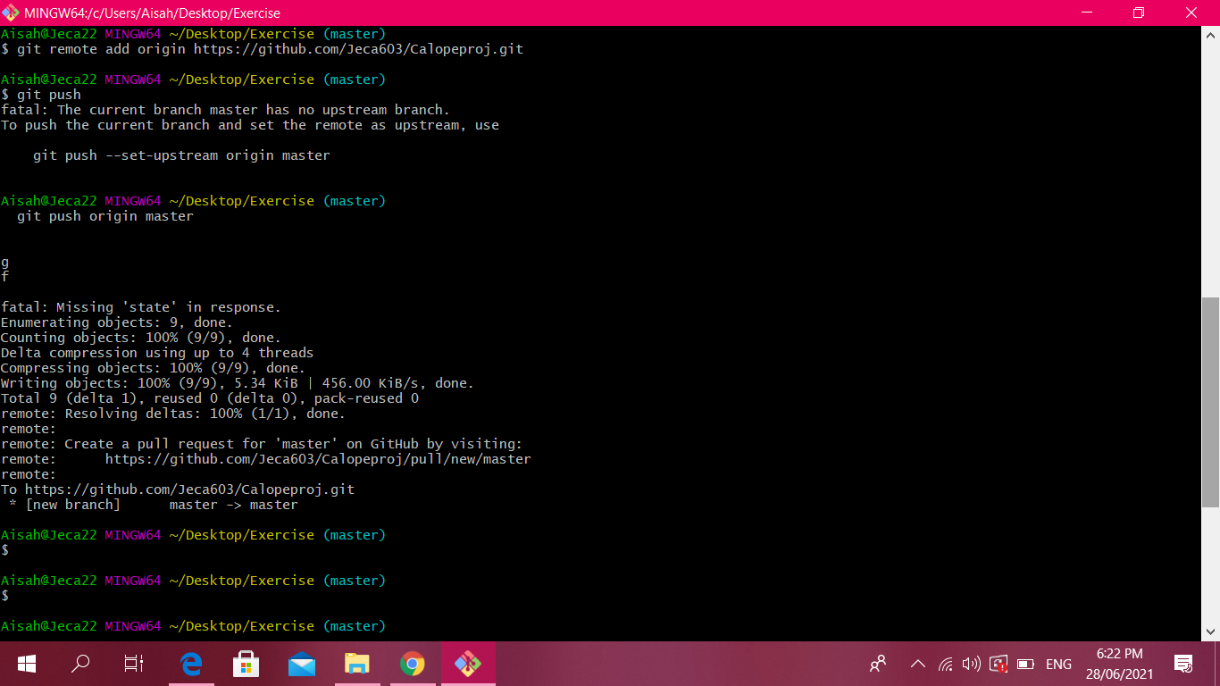

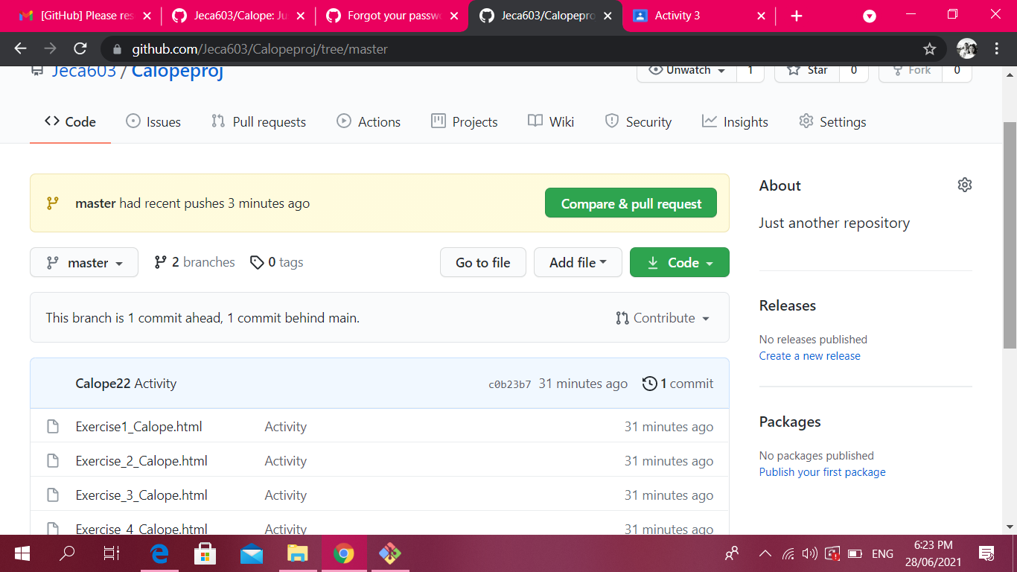

**Activity No. 4**

